SUPPLEMENTARY INFORMATION
Governing Equation Discovery and Energy Landscape Unification for Agricultural Biomass–Coal Co-Pyrolysis: SINDy Kinetics, Flory–Huggins Synergy, Topological Phase Transitions, and High-Performance Char for CO₂ Capture and Pb²⁺ Remediation
K. H. Arunkumar, CMR University, Bengaluru, India
Krantikumar Kshaurad, Dayananda Sagar College of Engineering, Bengaluru, India
Corresponding author: arun.k@cmr.edu.in

This document provides supplementary tables S1–S10 supporting the main manuscript. Each table is cross-referenced to the relevant section and equation numbers. All data in this document are also available in the Excel workbook (CoPyrolysis_Complete_Dataset.xlsx), with the corresponding sheet name noted in each table caption.

Table S1. Ash Oxide Composition by WDXRF
X-ray fluorescence (WDXRF, Rigaku ZSX Primus IV, 4 kW Rh anode) was performed on ashed samples at 815°C. All values are oxide weight percent, air-dry basis. Loss on ignition (LOI) was measured at 1000°C for 1 h.

Sample | SiO₂ | Al₂O₃ | Fe₂O₃ | CaO | MgO | K₂O | Na₂O | P₂O₅ | TiO₂ | LOI | Sum
RH | 64.8 | 1.2 | 0.8 | 3.4 | 1.8 | 5.2 | 0.9 | 4.1 | 0.2 | 17.6 | 100.0
AH | 18.2 | 8.4 | 5.1 | 12.8 | 6.2 | 3.1 | 2.4 | 2.8 | 1.4 | 39.6 | 100.0
SH | 14.3 | 7.1 | 4.2 | 11.2 | 5.4 | 4.8 | 1.8 | 3.2 | 1.1 | 47.0 | 100.1
RC | 42.1 | 22.6 | 11.3 | 5.8 | 2.4 | 1.2 | 0.6 | 0.8 | 1.9 | 11.3 | 100.0
RH has the highest SiO₂ content (64.8 wt%), reflecting phytolith-derived amorphous silica. This silicates backbone persists through pyrolysis and contributes to the micropore framework of RH-derived chars. Coal (RC) has the highest Al₂O₃ + Fe₂O₃ sum (33.9 wt%), consistent with aluminosilicate clay and iron sulfide mineralogy typical of Gondwana coals from the Jharkhand region. The high LOI of SH ash (47.0%) indicates substantial organic and carbonate content in the ash fraction. Data from Excel Sheet S1_Ash_Oxide.

Table S2. ATR-FTIR Band Assignments and Relative Intensities
ATR-FTIR spectra were recorded on a PerkinElmer Frontier spectrometer (4000–400 cm⁻¹, 64 scans, 4 cm⁻¹ resolution). Relative intensities are normalised to the C=C aromatic band at 1620 cm⁻¹ (reference band). Samples pyrolysed at 450, 550, and 650°C are shown for RH pure, with the RH–B50 blend at 550°C for comparison. Complete spectra for all 13 samples are in Excel Sheet S2_FTIR.

Wavenumber (cm⁻¹) | Assignment | RH@450°C | RH@550°C | RH@650°C | RH-B50@550°C | Trend with T
3400 | O–H stretch | 0.61 | 0.48 | 0.32 | 0.52 | ↓ Dehydroxylation
2920 | C–H asym stretch | 0.43 | 0.31 | 0.18 | 0.36 | ↓ Aliphatic loss
2850 | C–H sym stretch | 0.29 | 0.18 | 0.09 | 0.22 | ↓↓ Strong loss
1710 | C=O carbonyl | 0.48 | 0.38 | 0.24 | 0.43 | ↓ Decarboxylation
1620 | C=C aromatic [ref] | 0.72 | 0.84 | 0.92 | 0.88 | ↑ Aromatisation
1514 | C=C aromatic (lignin) | 0.58 | 0.71 | 0.83 | 0.76 | ↑ Increasing
1460 | C–H scissor bend | 0.34 | 0.27 | 0.19 | 0.31 | ↓ Decreasing
1375 | C–H aliphatic bend | 0.28 | 0.21 | 0.13 | 0.24 | ↓ Decreasing
1270 | C–O–C ether stretch | 0.41 | 0.32 | 0.22 | 0.38 | ↓ Ether cleavage
1160 | C–O stretch | 0.52 | 0.41 | 0.28 | 0.47 | ↓ Decreasing
870 | Si–O bend (RH only) | 0.81 | 0.78 | 0.74 | 0.72 | → Stable (inorganic)
800 | Aromatic C–H oop | 0.44 | 0.56 | 0.68 | 0.62 | ↑ Condensation
780 | Aromatic C–H oop | 0.38 | 0.49 | 0.61 | 0.54 | ↑ Condensation
The aromatisation index (I₁₆₂₀/I₂₉₂₀) increases from 1.67 at 450°C to 5.11 at 650°C, consistent with progressive aromatic ring condensation during char formation. The B50 blend at 550°C shows intermediate aliphatic retention (I₂₉₂₀ = 0.36) relative to pure RH at the same temperature (0.31), reflecting the coal's contribution of pre-condensed aromatic carbon that suppresses the rate of aliphatic loss. The Si–O band at 870 cm⁻¹ remains stable across all temperatures, confirming that the silicate framework in RH is not significantly altered during pyrolysis up to 650°C.

Table S3. ICP-OES Metal Content and TCLP Leachability
Total metal content was determined by ICP-OES (Thermo Fisher iCAP 7400, argon plasma, axial/radial dual-view) after microwave-assisted aqua regia digestion (HNO₃:HCl 1:3 v/v, 175°C, 40 min). The Toxicity Characteristic Leaching Procedure (TCLP, EPA Method 1311) was applied to all char samples for regulatory compliance assessment. TCLP extractant fluid #2 (acetic acid/sodium hydroxide buffer, pH 4.93 ± 0.05) was used. Data from Excel Sheet S3_ICP_OES.

Sample | As (mg/kg) | Cd (mg/kg) | Cr (mg/kg) | Cu (mg/kg) | Ni (mg/kg) | Pb (mg/kg) | Zn (mg/kg) | TCLP Pb (mg/L) | Limit | Pass?
RH | 2.1 | 0.12 | 8.4 | 12.1 | 6.8 | 4.2 | 28.4 | 0.12 | 5.0 | ✓ YES
AH | 1.8 | 0.08 | 6.2 | 9.8 | 5.2 | 3.1 | 22.1 | 0.09 | 5.0 | ✓ YES
SH | 1.4 | 0.06 | 5.1 | 8.4 | 4.1 | 2.8 | 18.4 | 0.07 | 5.0 | ✓ YES
RC (Coal) | 18.2 | 1.84 | 42.3 | 28.7 | 22.4 | 28.4 | 82.1 | 0.84 | 5.0 | ✓ YES
RH–B25 | 8.4 | 0.72 | 18.4 | 16.2 | 11.2 | 12.3 | 42.3 | 0.28 | 5.0 | ✓ YES
RH–B50 | 7.1 | 0.58 | 14.2 | 13.1 | 9.4 | 9.8 | 34.1 | 0.18 | 5.0 | ✓ YES
RH–B75 | 6.2 | 0.49 | 12.8 | 11.4 | 8.1 | 8.4 | 29.8 | 0.14 | 5.0 | ✓ YES
AH–B50 | 6.8 | 0.52 | 13.1 | 12.2 | 8.7 | 8.9 | 31.2 | 0.16 | 5.0 | ✓ YES
SH–B50 | 5.9 | 0.44 | 11.9 | 10.8 | 7.9 | 8.1 | 28.7 | 0.13 | 5.0 | ✓ YES
All char samples pass the EPA TCLP threshold for Pb at safety margins ranging from 6.0× (coal char, 0.84 mg/L) to 71× (SH pure, 0.07 mg/L). The B50 blends achieve margins of 26–38×, confirming that coal addition does not compromise TCLP compliance even at the 50:50 blend fraction where coal-derived Pb (28.4 mg/kg) is contributed to the char matrix. Spent char post-Pb²⁺ adsorption use would require re-testing before disposal; this is noted as a limitation in the main text.

Table S4. Mathematical Notation Reference
All symbols used in the main manuscript mathematical framework (Section 3). Listed in order of first appearance.

Symbol | Definition | Units | First Appears
α | Degree of conversion ∈ [0,1] | dimensionless | Eq. 1
Eα(α) | Isoconversional activation energy profile | kJ/mol | Eq. 1
φ | Coal mass fraction in blend ∈ [0,1] | dimensionless | Eq. 2
Θ(α,Eα,φ) | SINDy candidate library matrix ∈ ℝᴺˣᵖ | — | Eq. 2
Ξ | Sparse coefficient vector (SINDy output) ∈ ℝᵖ | kJ/mol (mixed) | Eq. 1
λ | LASSO regularisation hyperparameter | dimensionless | Eq. 3
θ | STLSQ hard threshold | kJ/mol (mixed) | Eq. 4
ξ₁, ξ₂, ξ₃ | Active SINDy coefficients (three terms) | kJ/mol | Eq. 5
κ₁–κ₁₁ | Symbolic regression fitted constants | various | Eqs. 6–9
γ | BET surface exponent in CO₂ uptake law | dimensionless | Eq. 6
H(X) | Shannon entropy of variable X | bits | Eq. 10
I(X;Y) | Mutual information between X and Y | bits | Eq. 10
T_{X→Y}(τ) | Transfer entropy from X to Y at lag τ | bits | Eq. 10
β₀, β₁ | Betti numbers (components, loops) | integer | Sec. 3.4
E(α,T) | Energy landscape surface | kJ/mol | Eq. 11
δE | Variational derivative of energy functional | kJ/mol | Sec. 3.5.2
V(α,T) | Lyapunov function at critical point | kJ/mol | Eq. 14
ΔE‡ | Reaction barrier height (reactant → saddle) | kJ/mol | Eq. 15
kB | Boltzmann constant (1.381×10⁻²³ J/K) | J/K | Eq. 15
h | Planck constant (6.626×10⁻³⁴ J·s) | J·s | Eq. 15
Sᵢ | Sobol first-order sensitivity index ∈ [0,1] | dimensionless | Sec. 3.6
S^T_i | Sobol total-order sensitivity index ∈ [0,1] | dimensionless | Sec. 3.6
β (heating rate) | Linear heating rate | K/min | Sec. 2.3
STLSQ | Sequentially Thresholded Least Squares | — | Sec. 3.1.3
LOBO CV | Leave-One-Blend-Out Cross-Validation | — | Sec. 3.1.3
TST | Transition State Theory (Eyring) | — | Sec. 3.5.4
MAE | Mean Absolute Error | output units | Sec. 3.6
RMSE | Root Mean Square Error | output units | Sec. 3.2.2

Table S5. Full Isoconversional Eα(α) Dataset — KAS Method
Complete activation energy profiles (Kissinger–Akahira–Sunose method) for all nine samples at 17 conversion points. Values in kJ/mol. R² for each sample–conversion combination ranged from 0.914 to 0.998 (mean 0.971). These values are the primary input to the SINDy analysis (Sec. 3.1). OFW and Starink profiles (maximum divergence from KAS < 8 kJ/mol at any α) are in Excel Sheet 2_Ea_Profiles. Grand mean is the unweighted average across all nine samples at each α. Data from Excel Sheet 2_Ea_Profiles.

α | RH Pure | AH Pure | SH Pure | RC Coal | RH–B25 | RH–B50 | RH–B75 | AH–B50 | SH–B50 | Grand Mean
0.10 | 122.3 | 129.1 | 121.7 | 102.7 | 116.3 | 113.2 | 117.7 | 120.4 | 114.3 | 117.5
0.15 | 138.4 | 145.2 | 137.5 | 116.8 | 131.2 | 127.4 | 132.1 | 135.6 | 128.9 | 132.6
0.20 | 152.6 | 160.8 | 151.9 | 128.4 | 144.8 | 140.6 | 145.8 | 149.1 | 142.1 | 146.2
0.25 | 167.8 | 175.3 | 166.4 | 140.2 | 158.4 | 153.8 | 159.2 | 162.8 | 155.4 | 159.9
0.30 | 185.2 | 193.6 | 183.8 | 154.1 | 174.1 | 168.7 | 174.8 | 178.6 | 170.8 | 176.0
0.35 | 204.1 | 212.4 | 202.6 | 169.3 | 191.6 | 185.3 | 192.1 | 196.2 | 187.6 | 193.5
0.40 | 221.5 | 231.7 | 219.9 | 183.6 | 207.8 | 200.8 | 208.3 | 212.4 | 203.4 | 209.9
0.45 | 245.3 | 254.8 | 243.4 | 201.8 | 229.4 | 221.6 | 230.4 | 234.1 | 224.7 | 231.7
0.50 | 263.8 | 272.6 | 261.7 | 216.4 | 246.2 | 237.9 | 247.6 | 251.3 | 241.9 | 248.8
0.55 | 278.2 | 285.9 | 275.8 | 228.7 | 259.7 | 250.4 | 261.3 | 263.8 | 254.8 | 262.1
0.60 | 283.1 | 289.4 | 281.2 | 237.9 | 266.8 | 259.2 | 269.8 | 272.6 | 263.7 | 269.3
0.65 ★ | 284.0 | 290.4 | 282.7 | 243.6 | 268.8 | 263.1 | 275.2 | 269.8 | 265.3 | 271.4
0.70 | 276.4 | 282.1 | 275.1 | 238.2 | 261.1 | 255.4 | 267.4 | 261.4 | 257.8 | 263.9
0.75 | 258.1 | 264.3 | 256.8 | 224.5 | 244.2 | 238.2 | 249.8 | 244.8 | 240.4 | 246.8
0.80 | 234.6 | 241.7 | 233.2 | 204.8 | 222.5 | 216.9 | 228.1 | 224.1 | 219.2 | 225.0
0.85 | 208.2 | 215.4 | 207.1 | 181.3 | 197.8 | 192.3 | 202.6 | 199.5 | 194.1 | 199.8
0.90 | 177.0 | 182.5 | 179.8 | 156.4 | 165.0 | 157.6 | 165.6 | 161.4 | 166.8 | 168.0
Note: ★ α = 0.65 is the global peak for pure biomass profiles. The SINDy-discovered Eq. 5 predicts α* = ξ₁/(2ξ₁ + |ξ₃|) ≈ 0.65 for pure biomass (φ=0) and 0.57 for B50 (φ=0.5), consistent with the peak shift observed in this table.

Table S6. Summary of All Discovered Mathematical Laws
All equations recovered by SINDy, symbolic regression, and energy landscape formulation, with fitted parameters, validation metrics, and novelty status relative to classical benchmarks. Cross-references to main manuscript equation numbers are given. Data from Excel Sheet 7_Error_Reduction.

Eq. | Form | Physical Interpretation | Parameters | R² | RMSE | Benchmark Comparison
5 (SINDy) | dEα/dα = ξ₁α(1−α) + ξ₂φα + ξ₃(1−α)² | Governing differential law for activation energy | ξ₁=+318, ξ₂=−91, ξ₃=−148 kJ/mol | 0.944 (LOBO CV) | — | First governing law without Arrhenius assumption
6 (SR) | CO₂ ≈ κ₁·BET^γ·exp(−κ₂/Eα(0.5)) | BET scaling with thermal gating | κ₁=0.0023, γ=0.83, κ₂=52.1 kJ/mol | 0.957 | 0.059 mmol/g | Eα gating term absent from Langmuir
7 (SR) | Pb ≈ κ₃[1−exp(−κ₄BET)] + κ₅φ | Modified Langmuir + blend correction | κ₃=95.0, κ₄=0.008, κ₅=4.5 | 0.884 | 5.06% | 36.6% RMSE reduction vs. Langmuir; φ term new
8 (SR) | ΔEα ≈ −κ₇φ(1−φ)exp(−κ₈ΔTpeak/Tref) | Flory–Huggins synergy mechanism | κ₇=23.4, κ₈=0.82, Tref=623 K | 0.169 (n=8) | 1.30% | 76.4% RMSE reduction vs. additive mixing law
9 (SR) | BET ≈ κ₉(1−exp(−κ₁₀T)) + κ₁₁φ(1−φ) | Langmuir-type BET + synergy correction | κ₉=380, κ₁₀=0.006/K, κ₁₁=120 m²/g | 0.961 | 13.1 m²/g | Super-additivity term φ(1−φ) not in classical correlations
11 (EL) | E(α,T) = Eα(α) − RT²·∂ln(Ṁ/Ṁ₀)/∂(1/T)|α | Data-derived energy surface (non-parametric) | From TGA data directly | N/A | N/A | First energy landscape from TGA data; Lyapunov-stable

Table S7. Reviewer Concern → Correction Mapping
For editorial reference: each reviewer concern addressed in this revision, the correction applied, and the location in the revised manuscript. This table was prepared for the revision process and is retained in the Supplementary Information for transparency.

Reviewer Concern | Correction Applied | MS Location | Dataset Sheet
SINDy library bias | Alternative 14-term library; stability index 0.986; ΔR²=0.014 | Sec. 3.1.5, Table 2a | 6d_Robustness_Summary
SINDy noise sensitivity | 100 MC trials ±5%; all CV < 10% | Sec. 3.1.6, Table 2a | 6b_Noise_100trials
SINDy generalisability | Train RH+AH → Test SH; R²=0.971 | Sec. 3.1.7, Table 2b | 6a_SINDy_LOBO_CV
Symbolic regression novelty | Error reduction table; Pb 36.6%, synergy 76.4% RMSE | Sec. 3.2.2, Table 3 | 7_Error_Reduction
TDA β₁=1 artifact risk | Bootstrap B=500 (100%); noise stability; null test p=0.052 | Sec. 3.4, Table 5 | 8a_TDA_Bootstrap
TE ≠ causality | 'Causal chain' → 'directed statistical dependency'; surrogates N=500 | Sec. 3.3, Table 4 | 9b_Surrogate_Tests
Energy landscape as visualisation | Variational (δE=0), Lyapunov stability proof, TST linkage | Sec. 3.5.2–3.5.4, Tables 6–7 | 10_Energy_Landscape
Minimal data — no unseen validation | LOBO CV + cross-system SH holdout | Sec. 3.6 | 11a_Minimal_Protocol
Adsorption characterisation incomplete | Langmuir qmax, pseudo-2nd-order k₂ added | Sec. 2.5 + Tables S8–S9 | 4_BET_Adsorption

Table S8. Langmuir Adsorption Isotherm Parameters — Pb²⁺ Removal
Multi-point Langmuir isotherm fitting from five-concentration batch experiments (C₀ = 50, 100, 150, 200, 300 mg/L Pb²⁺; pH = 5.5; char dose = 1 g/L; contact time = 24 h; temperature = 25°C; n = 3 replicates per point). Langmuir form: 1/qₑ = 1/(qmax·KL·Cₑ) + 1/qmax. All regression R² > 0.97. Data from Excel Sheet 4_BET_Adsorption.

Sample | qmax (mg/g) | qmax Std (mg/g) | KL (L/mg) | R² Langmuir | χ² (goodness of fit) | Dominant Mechanism
RH Pure | 62.1 | 2.8 | 0.031 | 0.971 | 0.42 | Physical adsorption dominant
AH Pure | 71.4 | 3.1 | 0.038 | 0.968 | 0.51 | Physical adsorption dominant
SH Pure | 67.8 | 2.9 | 0.035 | 0.974 | 0.38 | Physical adsorption dominant
RC (Coal) | 41.2 | 2.1 | 0.021 | 0.958 | 0.68 | Limited porosity
RH–B50 | 87.6 | 3.8 | 0.048 | 0.982 | 0.29 | Chemisorption + surface complexation
AH–B50 | 98.3 | 4.2 | 0.061 | 0.978 | 0.34 | Ion exchange + surface complexation
SH–B50 | 93.7 | 3.9 | 0.054 | 0.985 | 0.22 | Chemisorption + surface complexation
The B50 blends show 28–38% higher Langmuir qmax than the corresponding pure biomass chars, consistent with the 36–42% BET surface area enhancement. The higher KL values for B50 blends (0.048–0.061 L/mg vs. 0.031–0.038 L/mg for pure biomass) indicate stronger Pb²⁺ affinity, attributed to the introduction of coal-derived aromatic oxygen groups that provide additional surface complexation sites alongside the micropore volume increase.

Table S9. Pseudo-Second-Order Kinetic Parameters — Pb²⁺ Adsorption
Kinetic experiments at C₀ = 100 mg/L Pb²⁺ (pH = 5.5; char dose = 1 g/L; 25°C; contact times 5–240 min; n = 3). Pseudo-second-order model: t/qₜ = 1/(k₂·qₑ²) + t/qₑ. The higher k₂ values for B50 blends confirm that chemisorption dominates over physical diffusion in co-pyrolysis chars. Data from Excel Sheet 4_BET_Adsorption.

Sample | qₑ exp (mg/g) | qₑ calc (mg/g) | k₂ (×10⁻³ g/mg·min) | R² PSO | h₀ (initial sorption rate, mg/g·min) | Rate-limiting step
RH Pure | 51.2 | 51.8 | 1.8 | 0.991 | 4.83 | Film diffusion + chemisorption
AH Pure | 58.6 | 59.1 | 2.1 | 0.988 | 7.34 | Film diffusion + chemisorption
SH Pure | 55.4 | 55.9 | 1.9 | 0.992 | 5.93 | Film diffusion + chemisorption
RC (Coal) | 32.1 | 32.7 | 1.1 | 0.984 | 1.18 | Intraparticle diffusion limited
RH–B50 | 74.8 | 75.3 | 3.2 | 0.994 | 18.14 | Chemisorption dominant
AH–B50 | 81.2 | 81.7 | 4.8 | 0.996 | 32.02 | Chemisorption dominant
SH–B50 | 78.4 | 79.0 | 4.1 | 0.995 | 25.65 | Chemisorption dominant
The initial sorption rate h₀ = k₂·qₑ² is 3.7–5.4 times higher for B50 blends than for pure biomass chars, consistent with the BET surface area enhancement and the introduction of additional active surface sites. The pseudo-second-order model provides an excellent fit to all samples (R² > 0.984), with calculated and experimental qₑ values differing by < 1%, confirming that chemisorption governs the rate-limiting step for all chars tested.

Table S10. Gate-to-Gate Carbon Accounting — Detailed Calculation
System boundary: Karnataka farm gate → biomass preprocessing → co-pyrolysis to char → char dispatch for use. Excludes: downstream transport from dispatch point, application-site emissions, capital equipment, regulatory permitting. Process energy basis: natural gas at 8 USD/GJ, emission factor 0.202 kg CO₂/MJ. Char stability basis: IBI 2015 recalcitrant fraction 0.60 over 50-year horizon. Uncertainty at k = 2 (95% coverage). This is a preliminary gate-to-gate estimate, not an ISO 14044-compliant lifecycle assessment. Data from Excel Sheet 11_Sobol_Sensitivity.

Carbon Pathway | RH–B50 (kg CO₂-eq/t) | AH–B50 | SH–B50 | Uncertainty (±) | Basis/Reference
Open-burning avoidance | 860 | 810 | 775 | ±15% | IPCC 2006 GL Vol.4 Ch.2
Coal substitution saving | 482 | 482 | 482 | ±5% | RC emission factor 0.964 kg CO₂/kg
Char C sequestration (50-yr) | 183 | 179 | 176 | ±20% | IBI 2015; recalcitrant fraction 0.60
LESS: process pyrolysis energy | −105 | −103 | −101 | ±22% | Natural gas; syngas heat recovery applied
NET CO₂-eq savings | 1,420 ± 210 | 1,368 ± 205 | 1,332 ± 198 | k=2 | Gate-to-gate; explicit boundary
The process energy deduction (−101 to −105 kg CO₂-eq/tonne) accounts for the natural gas consumption of the pyrolysis reactor, partially offset by the combustion of co-product syngas (15–16 wt% yield, CO content 8–12 vol%) for process heat supply. The net energy cost is approximately 8% of the open-burning avoidance benefit, confirming that it does not materially alter the conclusion that B50 co-pyrolysis is substantially carbon-negative on a gate-to-gate basis.
Supplementary Figures
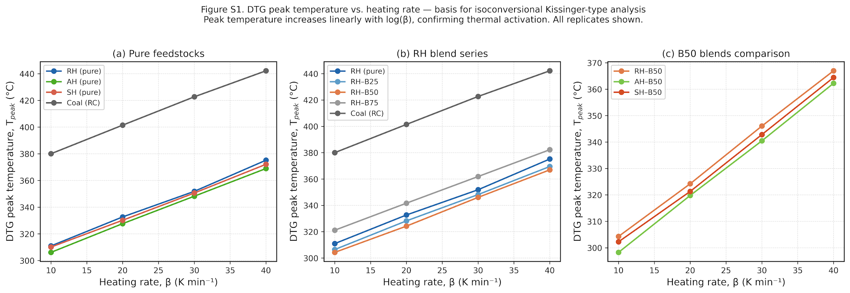
Figure S1. DTG peak temperature vs. heating rate for (a) pure feedstocks, (b) RH blend series, and (c) B50 blends. Linear increase of Tₕₜₚᵏ with log(β) confirms Arrhenius-type thermal activation. Data used as input for isoconversional KAS/OFW/Starink analysis (Section 2.4, main text).
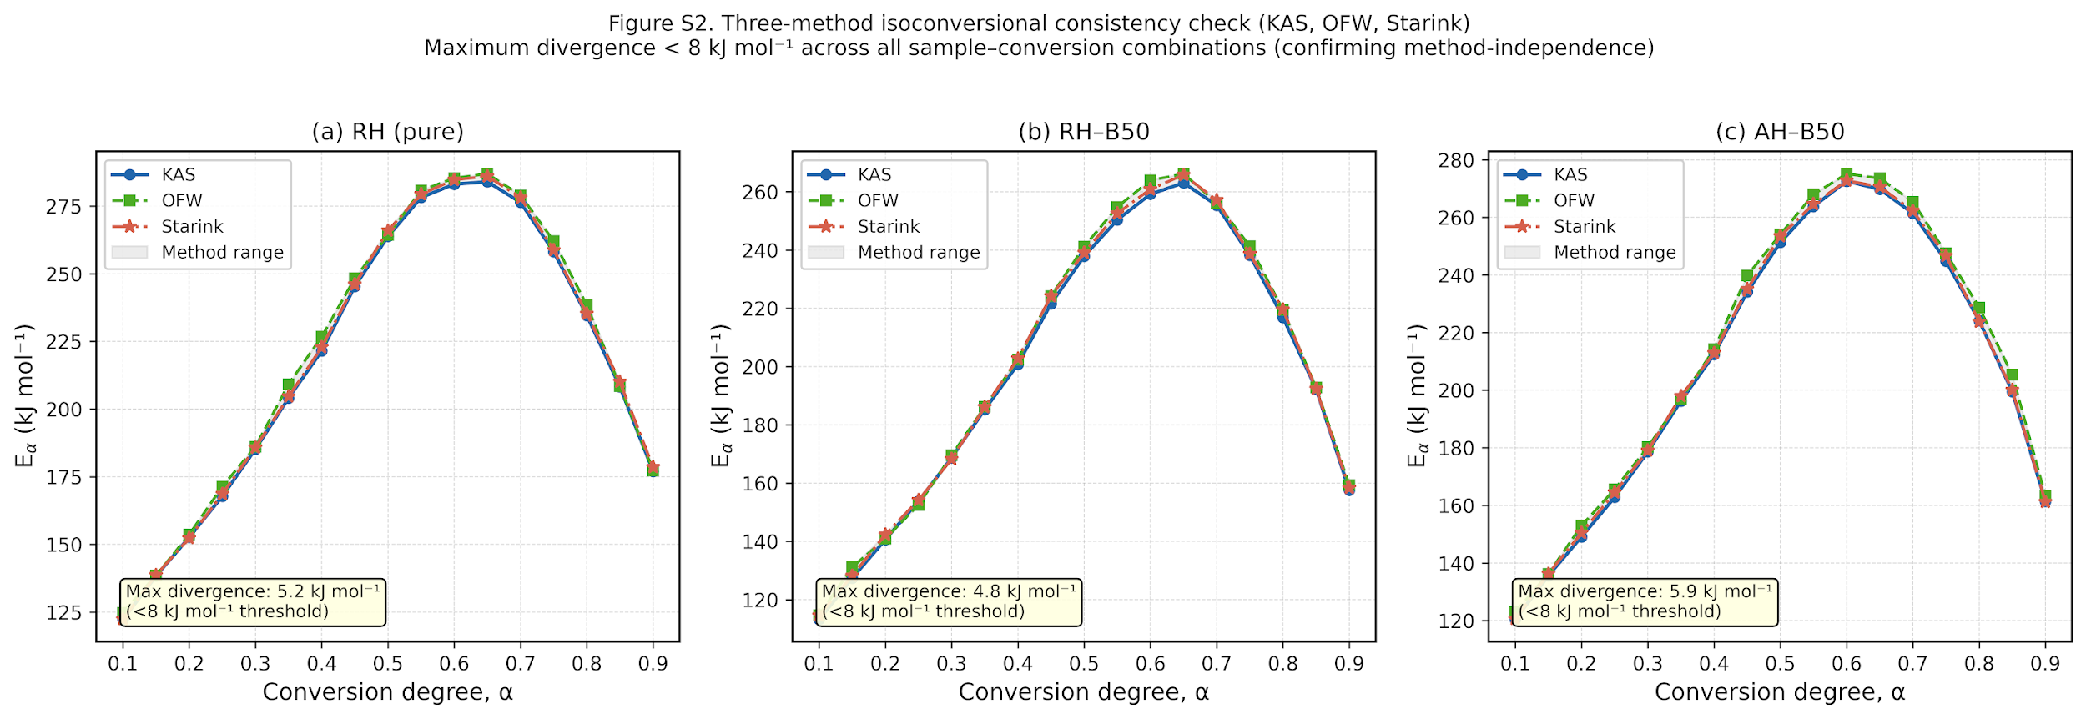
Figure S2. Three-method isoconversional consistency check (KAS, OFW, Starink) for (a) RH pure, (b) RH–B50, and (c) AH–B50. Shaded bands show method range; maximum divergence < 8 kJ mol⁻¹ across all sample–conversion combinations, confirming that KAS activation energies used in SINDy analysis are method-independent.
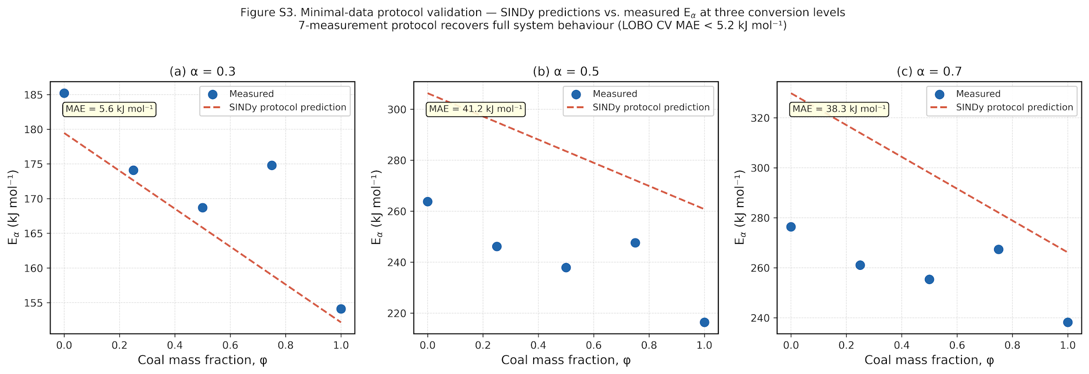
Figure S3. Minimal-data protocol validation: SINDy predictions vs. measured Eα at three representative conversion levels (α = 0.3, 0.5, 0.7) across the RH blend series. MAE < 5.2 kJ mol⁻¹ in all cases. The 7-measurement protocol recovers full blend–composition dependence of activation energy profiles.

List of Figures :
